Clustering – part II
There are different functions available in R for computing hierarchical clustering. The commonly used functions are:
- hclust() [in stats package] and agnes() [in cluster package] for agglomerative hierarchical clustering (HC)
- diana() [in cluster package] for divisive HC
In hierarchical clustering, the complexity is O (n^2), the output will be a Tree of merge steps. It doesn't require us to specify K or a mean function. Since its high complexity, hierarchical clustering is typically used when the number of points is not too high.

A simple example:
For the purpose of this example we can use mtcars dataset which is a dataset that was extracted from the 1974 Motor Trend US magazine, and comprises fuel consumption and 10 aspects of automobile design and performance for 32 automobiles (1973–74 models). Below is a brief description of the variables in the data set:
[, 1] mpg Miles/(US) gallon
[, 2] cyl Number of cylinders
[, 3] disp Displacement (cu.in.)
[, 4] hp Gross horsepower
[, 5] drat Rear axle ratio
[, 6] wt Weight (lb/1000)
[, 7] qsec 1/4 mile time
[, 8] vs V/S
[, 9] am Transmission (0 = automatic, 1 = manual)
[,10] gear Number of forward gears
[,11] carb Number of carburetors

data(mtcars)
# distance matrix
#method: the distance measure to be used. This must be one of "euclidean", "maximum", #"manhattan", "canberra", "binary" or "minkowski"
d <- dist(mtcars, method = "euclidean")
# The hclust() function allows the following agglomeration methods to be used: "ward", "single", #"complete", "average", "mcquitty", "median" or "centroid".
fit <- hclust(d, method="complete")
plot(fit, main="hierarchical clustering for mtcars dataset") # display dendogram
# draw dendogram with red borders around the 3 clusters
rect.hclust(fit, k=3, border="red")

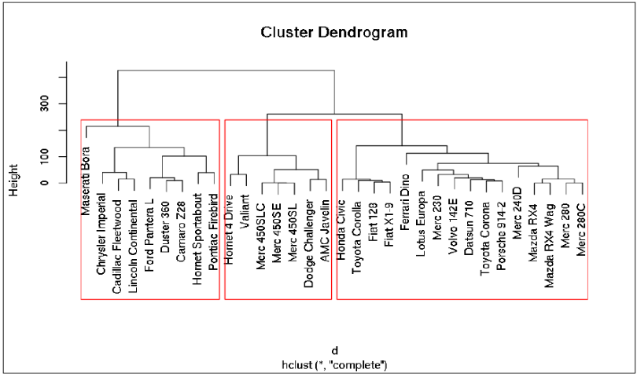
Although this graph looks nice and it is extremely useful to have similar elements grouped together, for bigger datasets, it becomes hard to see through. Instead, we might be rather interested in the actual cluster membership represented in a vector.

groups <- cutree(fit, k=3) # cut tree into 3 clusters

# The number of elements in the resulting clusters as a frequency table is given as
table(groups)

1 2 3
16 7 9
It seems that Cluster 1, the third cluster on the preceding plot, has the most elements. Can you guess how this group differs from the other two clusters?

round(aggregate(mtcars, FUN = mean, by = list(groups)), 1)

Group.1 mpg cyl disp hp drat wt qsec vs am gear carb
1 1 24.5 4.6 122.3 96.9 4.0 2.5 18.5 0.8 0.7 4.1 2.4
2 2 17.0 7.4 276.1 150.7 3.0 3.6 18.1 0.3 0.0 3.0 2.1
3 3 14.6 8.0 388.2 232.1 3.3 4.2 16.4 0.0 0.2 3.4 4.0

There's a really difference in the average performance and gas consumption between the clusters.

IRIS Dataset
Although, the Iris flower data set is a simple benchmark set for learning supervised classification algorithms, it is known however as a difficult case for unsupervised learning.
head(iris)
iris2 <- iris[,-5]
species_labels <- iris[,5]
The default hierarchical clustering method in hclust is “complete”. We can visualize the result of running it by turning the object to a dendrogram and making several adjustments to the object, such as: changing the labels, colouring the labels based on the real species category, and colouring the branches based on cutting the tree into three clusters.

d_iris <- dist(iris2)
hc_iris <- hclust(d_iris, method = "complete")
iris_species <- rev(levels(iris[,5]))

library(dendextend)
dend <- as.dendrogram(hc_iris)
# order it the closest we can to the order of the observations:
dend <- rotate(dend, 1:150)

# Color the branches based on the clusters:
library(colorspace) # get nice colors
dend <- color_branches(dend, k=3) #, groupLabels=iris_species)
# Manually match the labels, as much as possible, to the real classification of the flowers:
labels_colors(dend) <-
rainbow_hcl(3)[sort_levels_values(as.numeric(iris[,5])[order.dendrogram(dend)])]
# We shall add the flower type to the labels
labels(dend) <- paste(as.character(iris[,5])[order.dendrogram(dend)],
"(",labels(dend),")", sep = "")
# We hang the dendrogram a bit:
dend <- hang.dendrogram(dend,hang_height=0.1)
# reduce the size of the labels:
# dend <- assign_values_to_leaves_nodePar(dend, 0.5, "lab.cex")
dend <- set(dend, "labels_cex", 0.5)
# And plot:
par(mar = c(3,3,3,7))
plot(dend,
main = "Clustered Iris data set
(the labels give the true flower species)",
horiz = TRUE, nodePar = list(cex = .007))
legend("topleft", legend = iris_species, fill = rainbow_hcl(3))

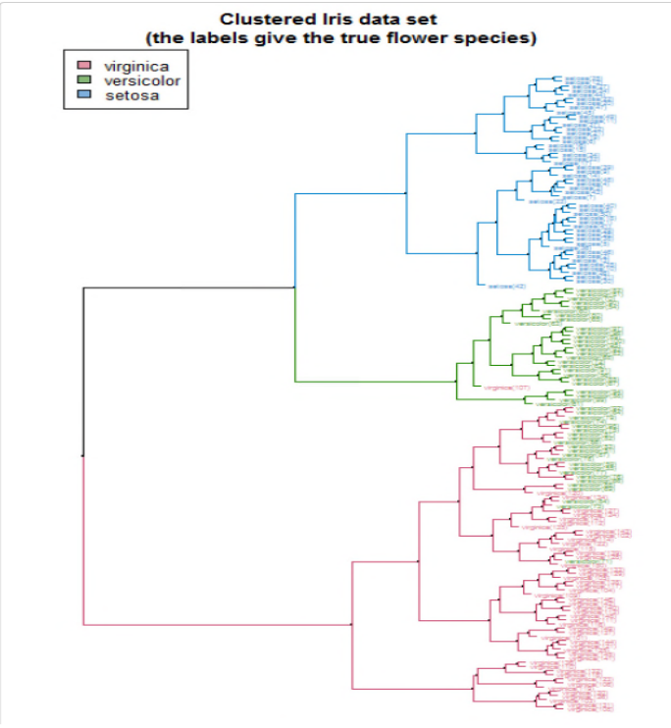
This visualization easily demonstrates how the separation of the hierarchical clustering is very good with the “Setosa” species, but misses in labeling many “Versicolor” species as “Virginica”. The hanging of the tree also helps to locate extreme observations. For example, we can see that observation “virginica (107)” is not very similar to the Versicolor species, but still, it is among them. Also, “Versicolor (71)” is located too much “within” the group of Virginica flowers.

We can also explore the data using a heatmap. The rows are ordered based on the order of the hierarchical clustering (using the “complete” method). The coloured bar indicates the species category each row belongs to. The colour in the heatmap indicates the length of each measurement (from light yellow to dark red). In the heatmap we also see how the Setosa species has low petal values (in light yellow), but it is very difficult to see any clear distinction between the other two species.

some_col_func <- function(n) rev(colorspace::heat_hcl(n, c = c(80, 30), l = c(30, 90), power = c(1/5, 1.5)))

# scaled_iris2 <- iris2 %>% as.matrix %>% scale
# library(gplots)
gplots::heatmap.2(as.matrix(iris2),
main = "Heatmap for the Iris data set",
srtCol = 20,
dendrogram = "row",
Rowv = dend,
Colv = "NA", # this to make sure the columns are not ordered
trace="none",
margins =c(5,0.1),
key.xlab = "Cm",
denscol = "grey",
density.info = "density",
RowSideColors = rev(labels_colors(dend)), # to add nice colored strips
col = some_col_func
)
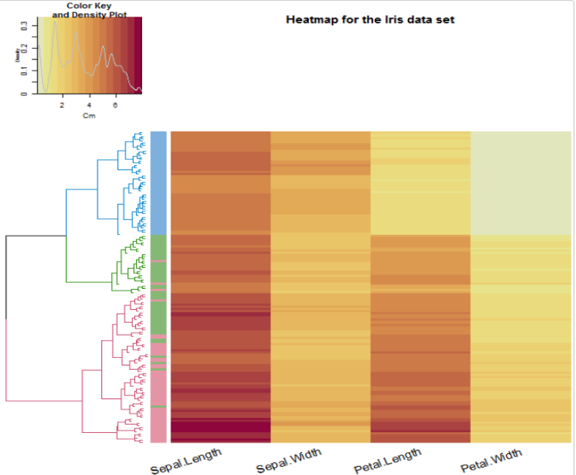
Similarity/difference between various clustering algorithms
We may ask ourselves how many different results we could get if we would use different clustering algorithms (hclust has 8 different algorithms implemented). For the purpose of this analysis, we will create all 8 hclust objects, and chain them together into a single dendlist object (which, as the name implies, can hold a bunch of dendrograms together for the purpose of further analysis).

hclust_methods <- c("ward.D", "single", "complete", "average", "mcquitty",
"median", "centroid", "ward.D2")
iris_dendlist <- dendlist()
for(i in seq_along(hclust_methods)) {
hc_iris <- hclust(d_iris, method = hclust_methods[i])
iris_dendlist <- dendlist(iris_dendlist, as.dendrogram(hc_iris))
}
names(iris_dendlist) <- hclust_methods
iris_dendlist

## $ward.D
## 'dendrogram' with 2 branches and 150 members total, at height 199.6205
##
## $single
## 'dendrogram' with 2 branches and 150 members total, at height 1.640122
##
## $complete
## 'dendrogram' with 2 branches and 150 members total, at height 7.085196
##
## $average
## 'dendrogram' with 2 branches and 150 members total, at height 4.062683
##
## $mcquitty
## 'dendrogram' with 2 branches and 150 members total, at height 4.497283
##
## $median
## 'dendrogram' with 2 branches and 150 members total, at height 2.82744
##
## $centroid
## 'dendrogram' with 2 branches and 150 members total, at height 2.994307
##
## $ward.D2
## 'dendrogram' with 2 branches and 150 members total, at height 32.44761
##
## attr(,"class")
## [1] "dendlist"
Next, we can look at the cophenetic correlation between each clustering result using cor.dendlist. (This can be nicely plotted using the corrplot function from the corrplot package):
iris_dendlist_cor <- cor.dendlist(iris_dendlist)
iris_dendlist_cor

## ward.D single complete average mcquitty median
## ward.D 1.0000000 0.9836838 0.5774013 0.9841333 0.9641103 0.9451815
## single 0.9836838 1.0000000 0.5665529 0.9681156 0.9329029 0.9444723
## complete 0.5774013 0.5665529 1.0000000 0.6195121 0.6107473 0.6889092
## average 0.9841333 0.9681156 0.6195121 1.0000000 0.9828015 0.9449422
## mcquitty 0.9641103 0.9329029 0.6107473 0.9828015 1.0000000 0.9203374
## median 0.9451815 0.9444723 0.6889092 0.9449422 0.9203374 1.0000000
## centroid 0.9809088 0.9903934 0.5870062 0.9801444 0.9499123 0.9403569
## ward.D2 0.9911648 0.9682507 0.6096286 0.9895131 0.9829977 0.9445832
## centroid ward.D2
## ward.D 0.9809088 0.9911648
## single 0.9903934 0.9682507
## complete 0.5870062 0.6096286
## average 0.9801444 0.9895131
## mcquitty 0.9499123 0.9829977
## median 0.9403569 0.9445832
## centroid 1.0000000 0.9737886
## ward.D2 0.9737886 1.0000000

corrplot::corrplot(iris_dendlist_cor, "pie", "lower")
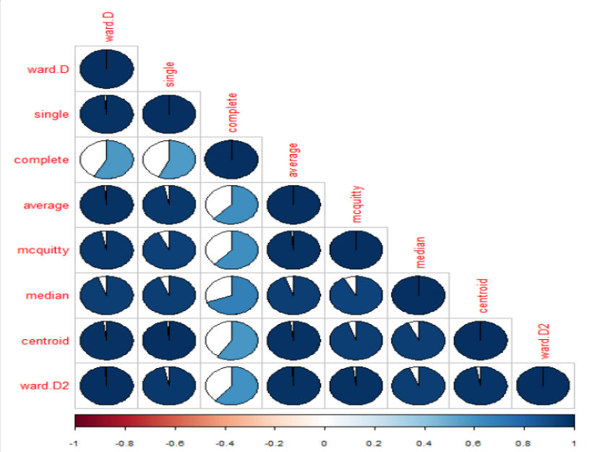
From the above figure, we can easily see that most clustering methods yield very similar results, except for the complete method (the default method in hclust), which yields a correlation measure of around 0.6.

WINE Data
Check the help of the functions dist and hclust: (check the method option of each function to see the different possibilities of computing distances and making hierarchical clustering based on these two functions)
library(ChemometricsWithR)
data(wines)

## Distance matrix for a subset of data:
subset <- sample(nrow(wines), 20)
wines.dist <- dist(wines[subset,])

## Single linkage clustering:
wines.hcsingle <- hclust(wines.dist, method = "single")
plot(wines.hcsingle, labels = vintages[subset])

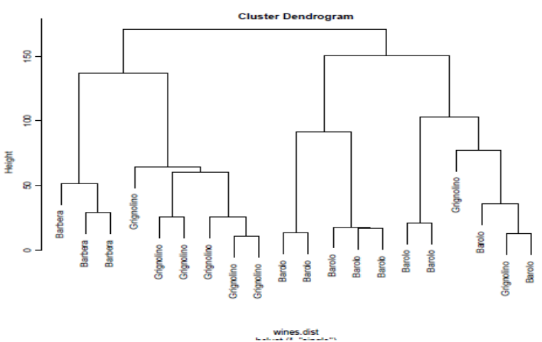
## Complete Linkage clustering:
wines.hccomplete <- hclust(wines.dist, method = "complete")
plot(wines.hccomplete, labels = vintages[subset])

# Ward Hierarchical Clustering
wines.hcward <- hclust(wines.dist, method="ward.D")
plot(wines.hcward) # display dendogram
groups <- cutree(wines.hcward, k=5) # cut tree into 5 clusters
# draw dendogram with red borders around the 5 clusters
rect.hclust(wines.hcward, k=5, border="red")

wines.cl.single <- cutree(wines.hcsingle, h = 3.3)
table(wines.cl.single, vintages[subset])

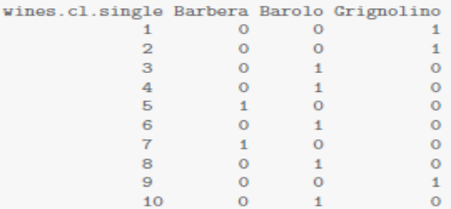
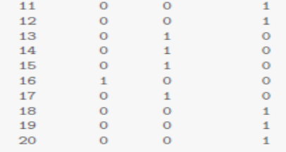

wines.dist <- dist(wines)
wines.hcsingle <- hclust(wines.dist, method = "single")
table(vintages, cutree(wines.hcsingle, k = 3))

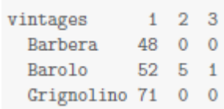

wines.hccomplete <- hclust(wines.dist, method = "complete")
table(vintages, cutree(wines.hccomplete, k = 3))

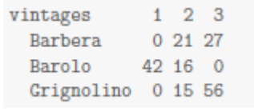

In addition, we can find a coefficient measuring the amount of cluster structure, the “agglomerative coefficient”, ac:

library(cluster)
wines.agness <- agnes(wines.dist, method = "single")
wines.agnesa <- agnes(wines.dist, method = "average")
wines.agnesc <- agnes(wines.dist, method = "complete")
cbind(wines.agness$ac, wines.agnesa$ac, wines.agnesc$ac)

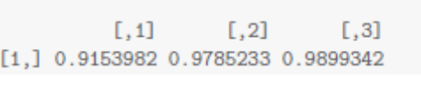

Fuzzy C-Means
Unlike K-Means where each data point belongs to only one cluster, in fuzzy cmeans, each data point has a fraction of membership to each cluster. The goal is to figure out the membership fraction that minimizes the expected distance to each centroids.
library(e1071)
> result <- cmeans(iris[,-5], 3, 100, m=2, method="cmeans")
> plot(iris[,1], iris[,2], col=result$cluster)
> points(result$centers[,c(1,2)], col=1:3, pch=8, cex=2)
> result$membership[1:3,]
1 2 3
[1,] 0.001072018 0.002304389 0.9966236
[2,] 0.007498458 0.016651044 0.9758505
[3,] 0.006414909 0.013760502 0.9798246
> table(iris$Species, result$cluster)
1 2 3
setosa 0 0 50
versicolor 3 47 0
virginica 37 13 0

